USER MANUAL
- Introduction
Welcome to Jungle Game, a strategic command-line board game where two players compete by maneuvering animal pieces across a jungle terrain. The objective is to either capture all opponent pieces or enter their den. The game enforces all official rules of Jungle (Dou Shou Qi), ensuring a fair and engaging experience.

- System Requirements
- Platform: Windows, macOS, or Linux
- Language Runtime: Python 3.x (e.g. 3.11-3.14)
- Interface: Command-line console (no GUI required)
- Dependencies: Only Python standard libraries

- Starting the game

To set up the terminal and ready for use, please make sure you have the right directory e.g. PS C:\\Users\\JungleGame\\game
To launch the game, simply click the run button or use the following commands in your terminal:
Action | Command
Start a new game | Python main.py
Load a saved game | Python main.py –-load <filename>.jungle
Replay a recorded game | Python main.py –replay <filename>.record
Enable debug logging | Python main.py --debug
Display version info | Python main.py --version

Player Naming
- You will be prompted to enter names for Player 1 (Red) and Player 2 (Blue).

- Press Enter without typing to generate random names.

- Supported Input Commands
Players take turns making moves. The game enforces all rules strictly — illegal moves are rejected with error messages.
Available Commands are as follow:
Command | Action | Example
(move)  <from> <to> | Move a piece | #chess notation: a0 b0 ;  *Coordinate notation: 0,0 1,0 ;  *Parentheses notation : (0,0) (1,0)  # alphabets for x-axis, num for y-axis  *y-axis, x-axis
undo | Undo the last move (up to 3 moves) | undo / u
save<filename> | Save game to .jungle file | save jungle1.jungle
load<filename> | Load game from .jungle file | load jungle1.jungle
record<filename> | Save move history to .record file | record match1.record
replay<filename> | Replay game from .record file | replay match1.record
help | Display help message | help / h
quit | Exit the game | quit / q

- Game Status Display
After each move, the game displays:
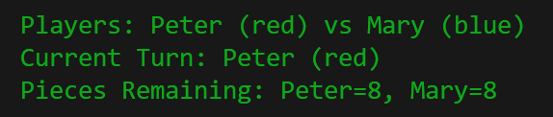
- Player names and current turn
- Remaining pieces for each player
- A grid-based board with terrain and piece symbols
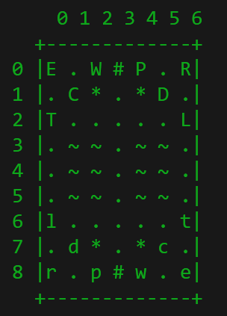
Terrain Legend
“.” = Land
“~” = Water
“#” = Den
“*” = Trap
Piece Legend
Symbol | Animal | Rank
R/r | Rat | 1
C/c | Cat | 2
D/d | Dog | 3
W/w | Wolf | 4
P/p | Leopard | 5
T/t | Tiger | 6
L/l | Lion | 7
E/e | Elephant | 8
- Uppercase = Blue Player
- Lowercase = Red Player
- Game Rules
Piece Ranking
- Higher-ranked animals can capture equal or lower-ranked enemies.
- Exception: Rat can capture Elephant; Elephant cannot capture Rat.
Movement Rules
- Pieces move one square horizontally or vertically.
- No diagonal movement.
- Cannot move into own den.
Water Rules
- Only Rat can enter water.
- Rat cannot capture from water to land or vice versa.
- Lion and Tiger can jump over rivers if no Rat blocks the path.
Capturing Rules
- Capture by moving onto an enemy piece.
- Any piece can capture enemies in trap squares, regardless of rank.

- Error Handling
Scenario | Message
Invalid command | “Unknown command”
Illegal move | “Move not allowed”
Rule violation | “Only rats can enter water”/  “Cannot move into own den”
File error | “Failed to load/save/replay game
Keyboard interruption | “Game interrupted by user”

- Ending the game
- Victory: Enter opponent’s den or eliminate all their pieces.
- Manual Exit: Use “quit” / “q” command.
- Final Message: “Thank you for playing Jungle Game!”

- FAQ
If you encounter any issues while playing the Jungle Game, please refer to the following options:
- For technical support or bug reports, please contact the development team at:
📧 Email: 23115372d@connect.polyu.hk

